FIN3210 Week 6 Assignment Report

Ma Kexuan 120090651

**Abstract**

This report used Nighttime Lights data and temperature data from GEE platform, to analyze the difference in several aspects between Shenzhen and Santa Clara.

**Data Preprocessing**

The preprocessing procedures and some interpretations of the code are described in the code attached to the report.

**Questions**

Q1: The two pictures are attached below. The left one is the occasionally lighted one, the right one is the continuous lighted one.

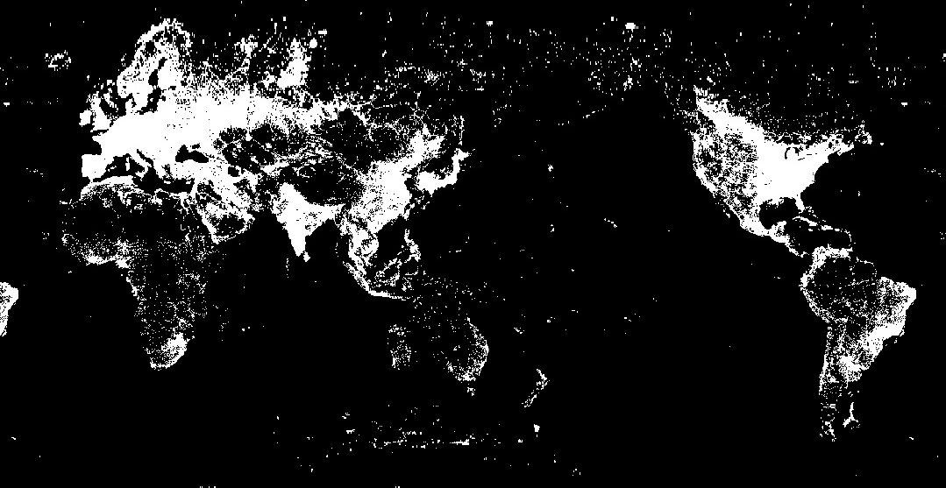 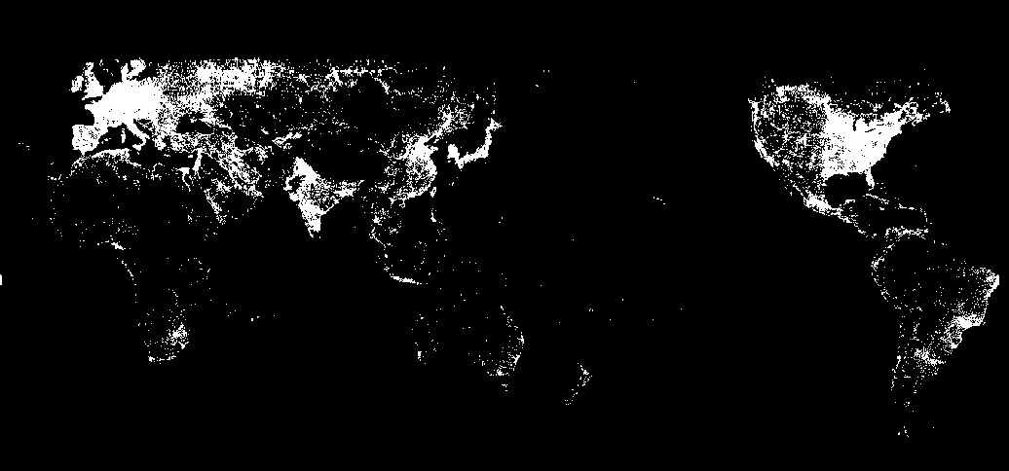

Nighttime light imagery, as showcased in the provided images, offers a unique perspective on global economic activity. The continuously lighted regions, evident in the right image, often denote established urban centers, signifying persistent economic endeavors such as New York's bustling commerce or Tokyo's sprawling metropolis. In contrast, the occasionally lighted areas in the left image hint at periodic or seasonal activities; for instance, coastal towns like Ibiza might light up during tourist seasons, while agricultural belts in Midwest America might glow during harvest months. Overlaying these insights paints a comprehensive picture of the world's economic pulse. Steady lights might indicate thriving economies with robust infrastructures, while fluctuating luminosity can suggest economic volatility or areas driven by transient events. Analyzing such imagery can guide policymakers in identifying developmental needs or economic opportunities, ensuring a more targeted approach to global growth and sustainability.

Q2: 1) Shenzhen, with an average yearly value of 54.447, exhibited more than double the nighttime luminosity compared to Silicon Valley, which had a value of 21.249. This disparity indicates that Shenzhen had a significantly higher degree of nighttime economic operations, potentially owing to its rapid industrial growth and bustling urban activities. Conversely, Silicon Valley, despite being a global tech hub, had lesser nighttime activities, reflecting a different economic and operational rhythm in its tech-driven ecosystem.

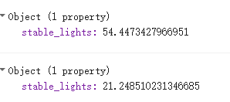

2) Due to the time series diagram attached below, throughout this period, Shenzhen exhibits a marked rise in light intensity, signifying its booming nighttime economy and rapid urbanization. Starting from values near 30, it ascends to above 50 by 2013. Conversely, Silicon Valley maintains a stable luminosity around the mid-20s, indicating consistent nighttime activities. While Shenzhen's surge reflects its evolution into a global manufacturing hub with increased nighttime operations, Silicon Valley's steadiness suggests that its technological innovation doesn't equate to heightened nighttime industrial activities. The graph underscores distinct economic dynamics of both regions.

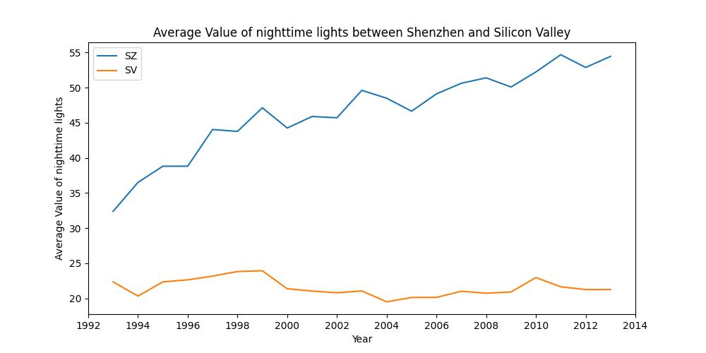

Q3: I conducted the 8-Day average value of daytime Land Surface Temperature between Shenzhen and Silicon Valley from 2020-01-25 to 2020-02-02 by the GEE platform. The findings reveal that Shenzhen had a slightly higher LST of approximately 17.63°C, while Silicon Valley, located in Santa Clara County, registered a temperature of about 15.26°C. Such temperature readings can be influenced by various factors, including urbanization, industrial activities, and vegetation cover. Shenzhen's elevated LST may reflect its high-density urban areas, extensive industrial operations, and reduced green spaces, which often lead to a heat island effect. On the other hand, Silicon Valley, while being a hub of technological innovation, might possess more green spaces or fewer heat-generating activities during this period, leading to its cooler LST. This temperature difference underscores the varying urban and environmental characteristics of the two regions.

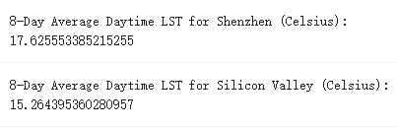

Appendices

Q1:

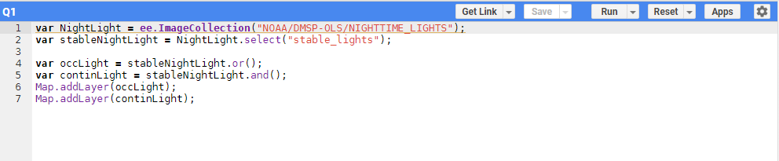

Q2:

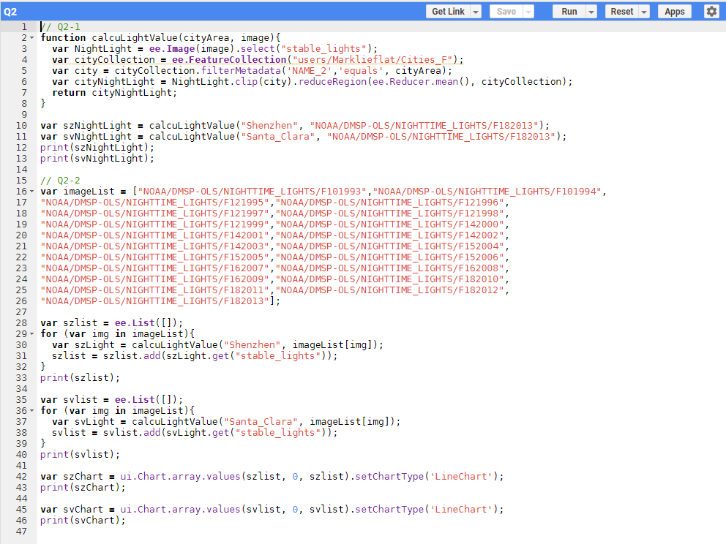

Q3:

